**Project Report**

**On**

**“Nearby location”**



**INTERNALGUIDANCE BY**

Bharat K Patel

Dipak patel

Ravi patel

**Developed BY:**

**Yash Thakar (126440307058)**

**Jaimin Gajjar (126440307071)**

**Pradip Patel (126440307062)**

**CERTIFICATE**

**B.S.PATEL POLYTECHNIC**

**GANPAT VIDYANAGAR, KHERVA**



**TO WHOM SO EVER IT MAY CONCERN**

This is to certify that following students of Diploma in computer engineering semester-5 have satisfactory completed project on “Nearby Location” for the subject Project-1 within the four walls of ”B.S.PATEL POLYTECHNIC” in academic year 2015.

|  |  |  |
| --- | --- | --- |
| **Sr. No.** | **Name of students** | **ENROLLMENT No.** |
| 1 | Yash Thakar | 126440307058 |
| 2 | Jaimin Gajjar | 126440316071 |
| 3 | Pradip Patel | 126440307062 |

[ Respected project guide ] [Respected H.o.d sir]

**ACKNOWLEDGEMENT**

**ACKNOWLEDGEMENT**

The satisfaction that accompanies that the successful completion of any task would be incomplete without the mention of people whose ceaseless cooperation made it possible, whose constant guidance and encouragement crown all efforts with success.

We hereby take this opportunity to thank everyone who has directly or indirectly helped us in preparing our project on **“Nearby Location”.**

We are thankful to **Mr. Bharat patel** and Mr.**ravi patel** who had given a nice guidance & support to us to fulfil and complete the project within duration.

Thanks to All those valuable suggestion and comments the text has benefited so much. We express our gratitude towards all faculty members who have guided and directed us at every moment to fulfil our mission and produce this work in front of you. We hope you would undoubtedly find the matter interesting and information as well. At last thank to all users for their interest in our work. With Sincere Regards From,

**ABSTRACT**

## ABSTRACT

* The purpose of developing “N**earby location”** is to computerized the tradition way of taking the price list then ask for offers and discounts. Another purpose for developing this website is to get the real time discounts and offers which are updated every time.

* To make a website which shows nearby café or store with real time discounts and offers.

#####  System will provide following features:

* Manual Work Has To Be Reduced And Result To Be Received

Quickly.

* To Speed Up The Operation And Decrease Manpower, High Cost .
* Increase Speed, Storing and Accuracy.

**PREFACE**

**PREFACE.**

Experience is the best teacher; this saying has played a guiding role in project as a part of curriculum of Gujarat Technological University. This project allows students to practically experience and develop an understanding about the difficulties and the challenges to the Technological world. Only theory knowledge does not impart complete education, practical experience must accompany theoretical knowledge to add meaning to the education. To fulfill the objective this project is a part of Diploma ce program. in this direction we have tried our level best to present a project report based on Nearby location. The successful completion of this report would not have been possible without co-operation and support of our project guide samarth sikotra and hitesh jotaniya.

**INDEX**

|  |  |  |  |  |
| --- | --- | --- | --- | --- |
| **Index No.** | **Sr.**  **No.** | **Sub No.** | **Topic** | **Page no.** |
| 1 |  |  | INTRODUCTION | 11 |
|  | 1.1 |  | Project Profile | 12 |
| 2 |  |  | PROJECT SPECIFICATION | 13 |
|  | 2.1 |  | Project Definition | 14 |
|  | 2.2 |  | Scope of our project | 15 |
|  | 2.3 |  | User of our project | 16 |
| 3 |  |  | PROJECT PLANNING | 17 |
|  | 3.1 |  | System Requirement Documentation | 18 |
| 4 |  |  | SYSTEM REQUREMENT | 22 |
|  | 4.1 |  | Technology And Language used | 23 |
| 5 |  |  | SYSTEM DESIGN | 28 |
|  | 5.1 |  | Dataflow Diagram | 29 |
|  |  | 5.1.1 | Login Page | 29 |
|  |  | 5.1.2 | Home Page | 30 |
|  | 5.3 |  | Data Dictionary | 36 |
|  |  | 5.3.1 | TABLE NAME:LOGIN | 36 |
|  |  | 5.3.2 | TABLE NAME:REGISTRATION | 37 |
|  |  | 5.3.3 | Cafes and places | 38 |
| 6 |  |  | screen shots | 41 |
| 7 |  |  | bibliography | 53 |

* 1. **INTRODUCTION**

#### 1.1 PROJECT PROFILE.

|  |  |
| --- | --- |
| **Project-title** | **Nearby location** |
| **Created By** | **Yash Thakar**  **Jaimin Gajjar**  **Pradip Patel** |
| **Purpose** | **Providing Peoples the nearby location**  **With the offers and discounts**  **And notify them.** |
| **Front-End** | **PHP, Google API** |
| **Back-End** | **MYSQL** |
| **Language** | **HTML** |

**2. Project Specification**

#### 2.1 PROJECT DEFINATION.

Aim :- To make a website which shows nearby café

or store with real time discounts and offers .

Example: - if you are around pizza hut but you

Don’t know offers about your nearby

Pizza hut’s discounts and offers.

Then this site indicates all the discounts

And offers.

**2.2 SCOPE OF Nearby location.**

01. It provides people to get information about their by location.

02. It is contains all the needed offers and discounts.

03. It is basically a search engine which links you to the perfect location.

#### 2.3 USERS OF Nearby location.

1. Authenticated Users or Registered Users.

1. All who are interested

1. **Registered Users or Authenticate Users:**

The Users of the website, who have authority to view the website, search and locate their result.

Registered users have to also authority to access

Their location and other location and special offers too.

1. **Administrative Users:**

The users or controllers of the website they have fully authority to control the website.

They also decide which offers are to be shown.

**3. PROJECT PLANNING**

#### 3.1 System Required Document (SRS)

❖ **System Analysis:**

1. **Preliminary Investigation**
2. **Feasibility Study**

**1) Preliminary Investigation:**

* **An overview of nearby location website.**

Now in world of faster technology, nobody have extra time to go and ask the offers and discounts. So creating the solutions from which they get information as well as save their valuable time

* **Limitations of manual system:**

* + Whole the procedure is much complicated.

* + When all works are gone through manually there are many chances for „error‟ because it is done by human being.

* + Service in manual system is not satisfactory.

* + Person cannot get latest information because the offers are hear by another person’s.

* + Man can make mistakes in writing figures

* **Why Computerization?**

As said above, it requires skilled and very alert person a work with it through there may be chances of mistakes. Therefore to overcome that limitation it is better to develop computerized system because computer is best for this purpose. Particularly to manage large volume of data and updatable of latest information.

**Merits of computerized system:**

* + Computer can work fast and with accuracy.
  + Software updatation process becomes faster.
  + Persons with primary knowledge of Web-site maintenance can operate computer based system.
  + There is no occasion of occurrence of mistakes.
  + To get any information of any person is much easier and one can get quickly.
  + All procedures becomes much faster than manual system.
  + In computer based system if we make one entry, then further related all other processes would be done automatically.
  + Computerized system can function any work for many times with the same accuracy.
  + No chance of data redundancy.
  + Easily Software Downloading.
  + It is balancing procedure.

2 **Feasibility Study:**

After seeing the limitation of manual systems, internet

and benefit of computerized one must think to develop a computerized search engine for nearby location but before that we must know whether it is feasible for any Organization or not.

One should consider feasibility in all aspect mainly we should check three types of feasibility.

* Economic Feasibility.

❖ Technical Feasibility.

* Operational Feasibility.

**I. Economic Feasibility:**

Economic analysis is the best method for evaluating the effectiveness of our system. To develop computerized system, Person or organization needs good personal computers and Internet facility.

Now a days, computer price going down and Personal can afford that much cost. Also save valuable time and makes faster transaction.

Because in my website, the following requirements are must be fulfilled which is very less costly.

**Operating System : - Windows - 98 / 2000 / XP / 7/8/8.1/10**

**Minimum System Requirement: - Pentium – I / II /III with**

**512 MB RAM**

**160 GB Hard Disk**

So the above system requirement is economically feasible for any Person.

**II.Technical Feasibility:**

Here one should consider that to develop a new computerized security solution system is technically possible or not. In our case we need some software and some hardware. Which are easy available in market or we can develop a website according to our need and full PC is easily available so technically it is feasible to develop a computerized system.

1. **Operational Feasibility :**

Here we should check that operating of that system is easy or not or one can operate easily. Our website of nearby location as a search engine is “User Friendly” where any new visitor can operate that system easily without knowledge of computer.

**4. SYSTEM REQUIREMENT**

**4.1 Technology and Language used:**

**Hardware-Used:**

* **Server Side :-** Minimum Core 2 Duo & above Processor

2GB RAM

* **Client Side :-** Minimum Pentium 4 & above Processor

512 MB RAM

**Software-Used:**

* **Front-end :-PHP**

PHP is a scripting language that lets you create dynamic Web pages. PHP is a server-side scripting language. The PHP language interpreter must be installed on the server-side in order to execute PHP commands. When a page containing PHP commands is requested from a PHP enabled server, the server hands over the page to the PHP interpreter. The output (usually in the form of HTML) of the interpreter execution is sent back to the client that requested the page. Thus, a dynamic Web page is created. If you are familiar with the basic C syntax you won't have problems with the PHP syntax. PHP makes it possible to perform mathematical calculations, to handle regular expressions, to control the flow of a program execution, to send e-mails, to establish network connections, even to define classes and create instances of these classes as in any other object-oriented programming language. However, PHP is the best known for its database interfacing capabilities. With PHP you can establish a database connection to any of standard database servers (such as Oracle, Informix, MySQL and much more), perform queries, update the content of a database, and even manipulate a particular database schema. The results of queries are easily converted into a valid HTML that is sent back to a client. Currently, PHP seems to be the best technological solution for providing a WWW gateway to a database server. One of the reasons that PHP is so powerful is that is a goal-oriented language. It is made to accomplish things, quickly and easily.



PhpMyAdmin can manage a whole MySQL server (needs a superuser) as well as a single database. To accomplish the latter you'll need a properly set up MySQL user who can read/write only the desired database. It's up to you to look up the appropriate part in the MySQL manual.

Currently PhpMyAdmin can:

* Create and drop databases.
* create, copy, drop, rename and alter tables.
* do table maintenance.
* delete, edit and add fields.
* execute any SQL-statement, even batch-queries.
* manage keys on fields.
* load text files into tables.
* create (*) and read dumps of tables.
* export (*) data to CSV, XML and Latex formats.
* administer multiple servers.
* manage MySQL users and privileges.
* check referential integrity in MyISAM tables.
* using Query-by-example (QBE), create complex queries .automatically connecting required tables.
* create PDF graphics of your Database layout.
* search globally in a database or a subset of it.
* transform stored data into any format using a set of predefined functions, like displaying BLOB-data as image or download-link or ...
* Support InnoDB tables and foreign keys .
* Support MySQL, the improved MySQL extension .

Communicate in 47 different languages

➢ **Back-end** : -**MySQL**

MySQL is an open source, SQL Relational Database Management System (RDBMS) that is free for many uses. One of the most powerful features that PHP offers is its database connectivity. It has never been so easy to connect to a database management server, to update the content of a particular database, or to retrieve the data from a particular database, as it is the case by means of using simple PHP scripts. Another very useful PHP feature is that a standard PHP distribution comes with a number of standard function libraries which allow users to write scripts that connect to a wide range of currently popular database management systems. There is, for instance, a function library for manipulating MySQL databases, Oracle databases, Informix database and much more. There are several different steps that script executes:

The script uses the MYSQL_CONNECT () function in order to establish a connection to the MySQL server. The MYSQL_CONNECT

() function takes three values as its arguments:

* 1. Hostname - the name of the host to which to establish the connection. In our case it is the local host because both servers: the Web server and the MySQL server are running on the same machine.
  2. Username - the name of a user that has privileges to manipulate the test database that we created.
  3. Password - the valid password of the user.



Apache acts as your Web server. Its main job is to parse any file requested by a browser and display the correct results according to the code within that file. Apache is quite powerful and can accomplish virtually any task that you, as a Webmaster, require.

* Password-protected pages for a multitude of users.
* Customized error pages.
* Display of code in numerous levels of HTML, and the capability to determine at what level the browser can accept the content.
* Usage and error logs in multiple and customizable formats.
* Virtual hosting for different IP addresses mapped to the same server.
* Directory Index directives to multiple files.
* URL aliasing or rewriting with no fixed limit .

**HTML**

HTML was originated by Tim Berners-Lee.. HTML is a computer language devised to allow website creation. HTML is Hyper Text Markup Language. It consists of series of short codes typed into a text-file by the site author-these are tags. The text is then saved as a HTML files, and viewed through a browser, like Internet Explorer or Mozilla Firefox. These browsers read the file and translate the text into visible form. HTML document file extension is „html‟ or „htm‟.

**JavaScript**

JavaScript is an interpreter, object-based scripting language. Although it has fewer capabilities than full-fledged object-oriented language like C, C++ and java, JavaScript is more that sufficiently powerful for its intended purpose.

JavaScript is not cut-down version of any other language (it is only distantly and indirectly related to java), and it is not a simplification of anything. It is, however, limited. You can‟t write standalone application in it, for example, and it has little capability for reading or writing files. Moreover, JavaScript scripts can run only in the presence of an interpreter, either in web browser.

**5. SYSTEM DESIGN**

5.1.1) Home Page:

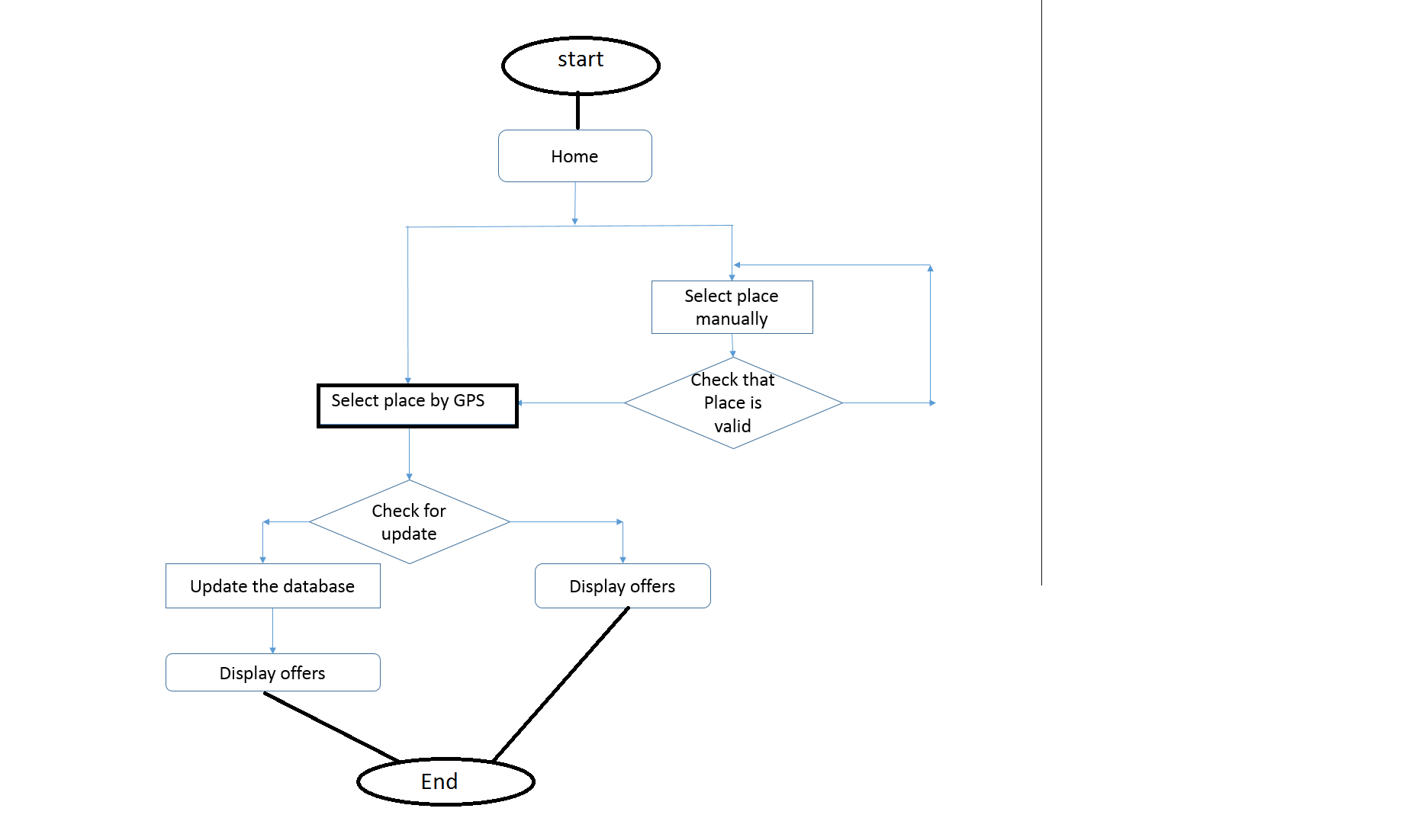

Login page:-

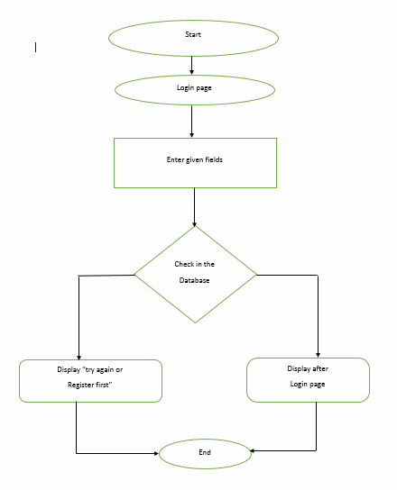

Offer :

-

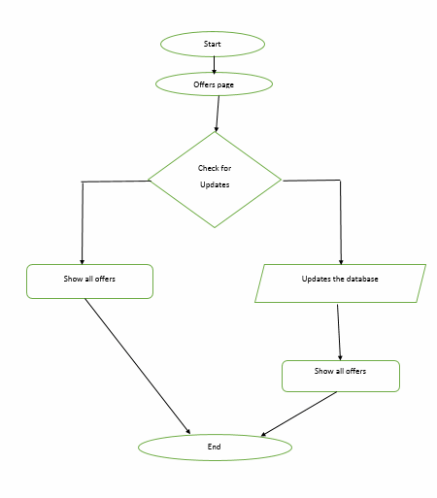

Registration:-

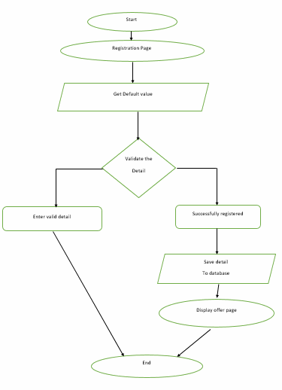

**DFD: -**

**I. 0 level DFD:-**

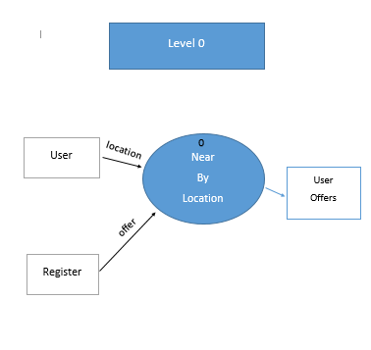

**User level 1:**

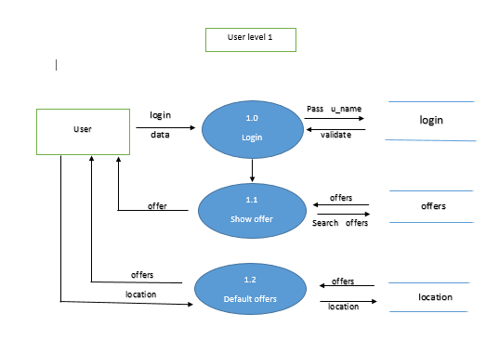

**User register _level 1**

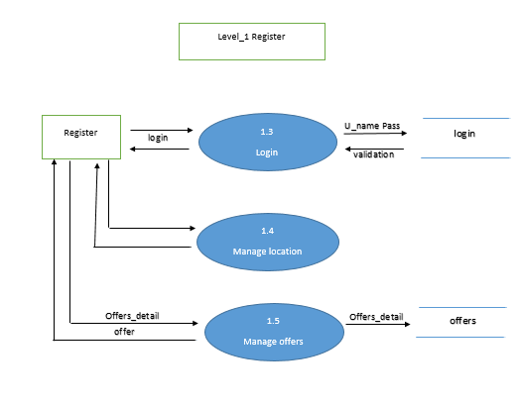

**Level 2 DFD: -**

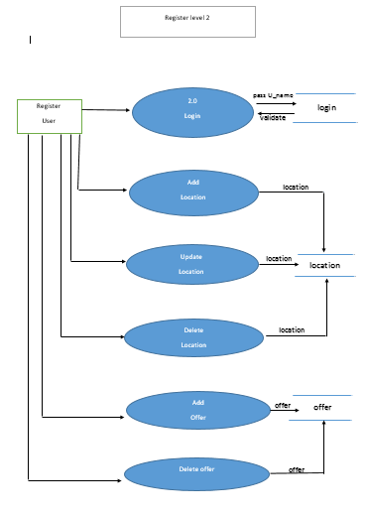

**Use case Model**

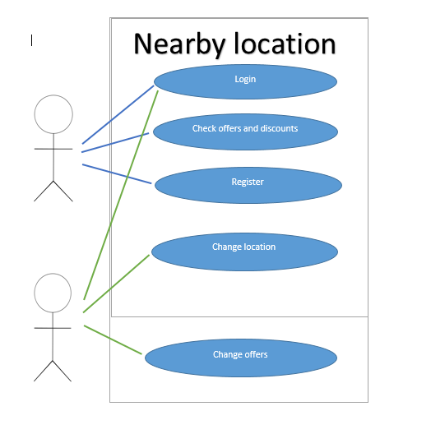

#### 5.3 Data Dictionary

**5.3.1) Table Name: Login**

Purpose: This table is used to get access controls of the user for the security purpose of web applications.

|  |  |  |  |
| --- | --- | --- | --- |
| **Column Name** | **Data Type** | **Constraint** | **Description** |
| User name | Varchar(20) | Primary key | Unique id of user |
| Password | Varchar(10) | Not Null | Password of user |

**5.3.2) Table Name: Registration**

Purpose: This table is used to collect the information of the user so no one else can get access to the web application without Logging in.

|  |  |  |  |
| --- | --- | --- | --- |
| **Column Name** | **Data Type** | **Constraint** | **Description** |
| Id | Int(20) | Foreign key, unique | User identification |
| Name | Vachar(30) | Not Null | name of the user |
| Your E-mail | Vachar(20) | Not Null | E-mail id of the user to check weather user is valid or not |
| Re-enter your E-mail | Vachar(20) | Not Null | Re entry of E-mail id of the user |
| Password | Vachar(32) | Not Null | Password of the user which user wants to choose |
| Conformpassword | Vachar(32) | Not Null | Re enter password to check password does match above passwordor not |
| Birthdate | Date | Not Null | Birthdate of user |
| location | Varchar(30) | Not Null | The location of the user |

**5.3.3 Cafes or places**

|  |  |  |  |
| --- | --- | --- | --- |
| Coloum name | Data type | Constraint | description |
| Name | Varchar(30) | Not null | Name of the place |
| City | Varchar(25) |  | Name of the city |
| Location_lat | double | Not null | Latitude of the place |
| Location_lon | double | Not null | Longitude of the place |
| Created_at | Int(11) |  | When its is created |
| Updated_at | Int(11) |  | When it is updated |

**6 Screen shots**

**Home page(index)**

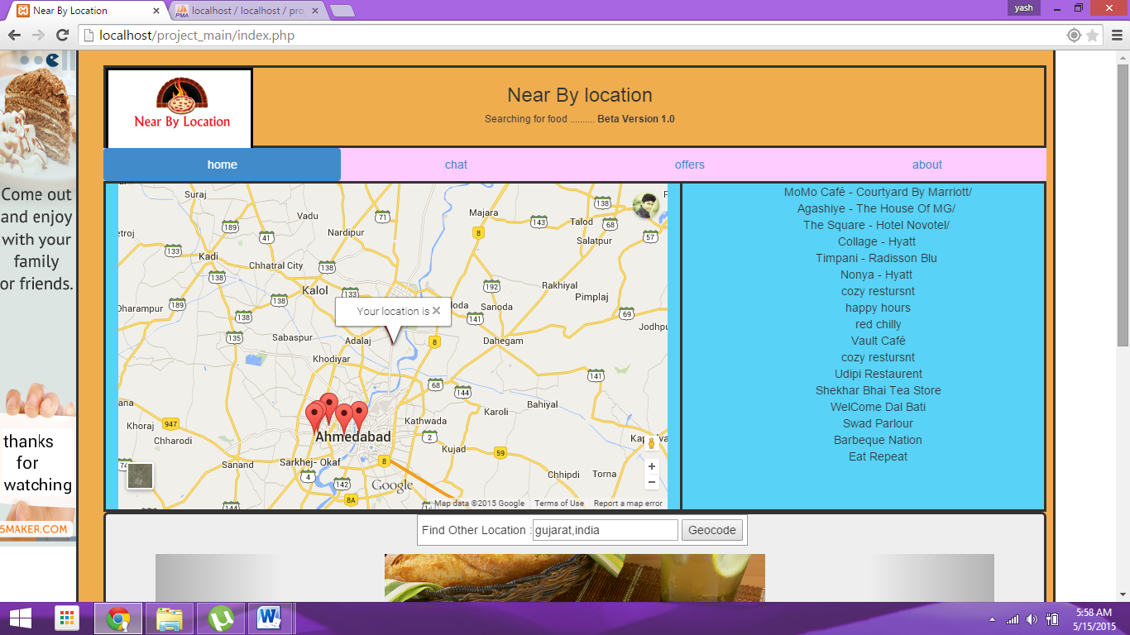

**Marker clicked**

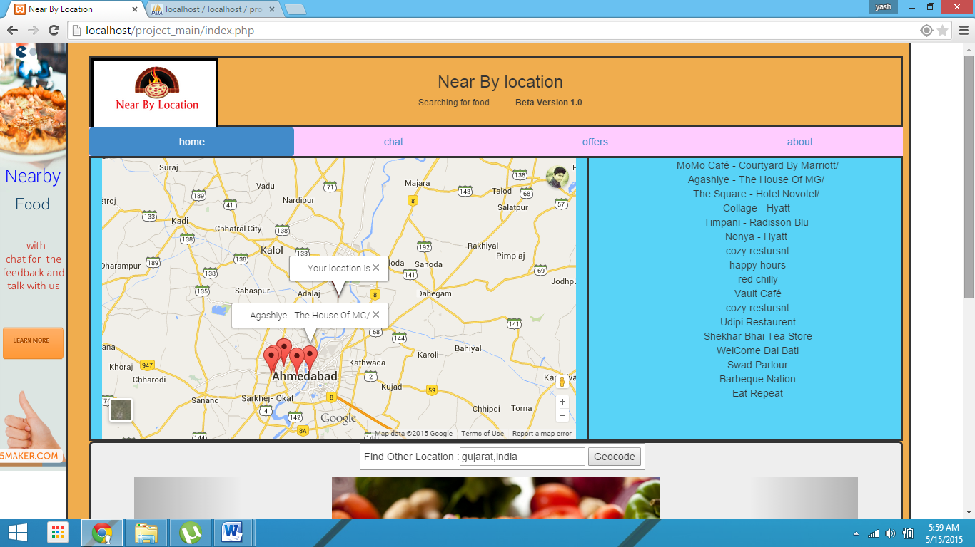

**Searching for geocode**

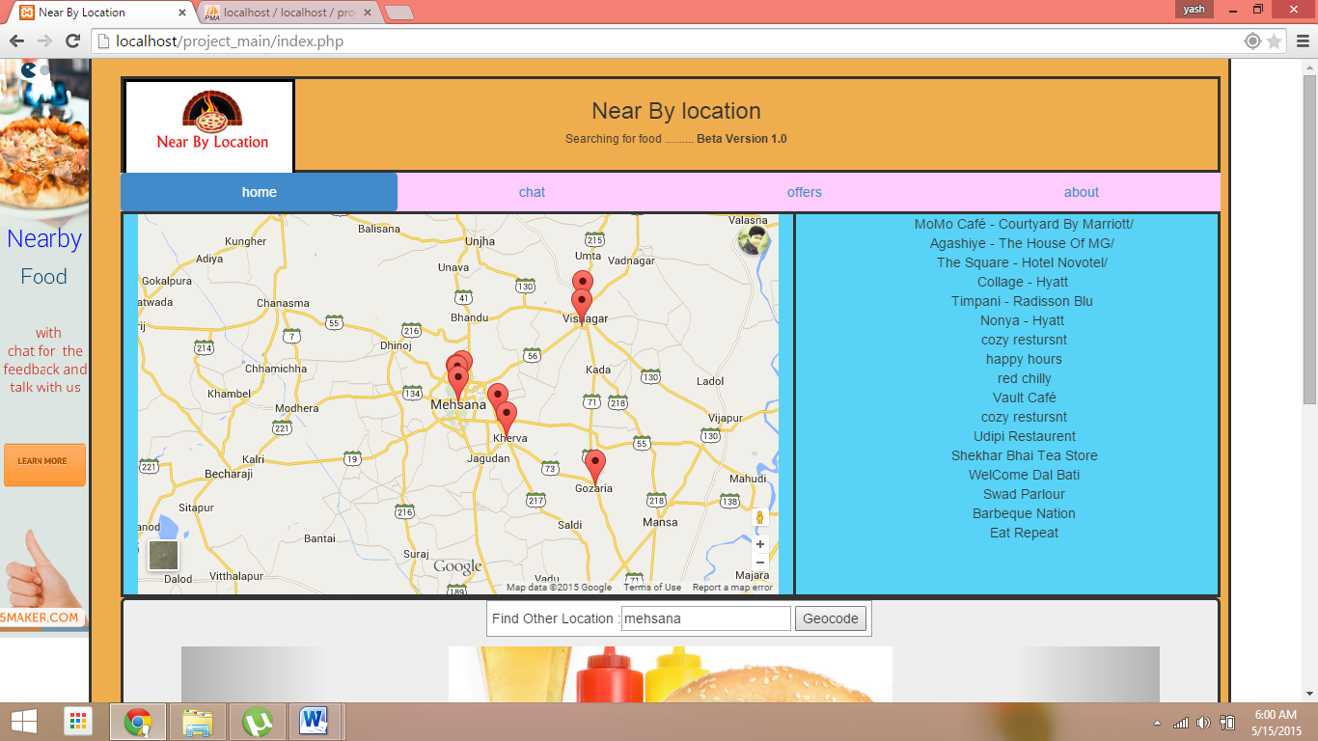

**Developer section**

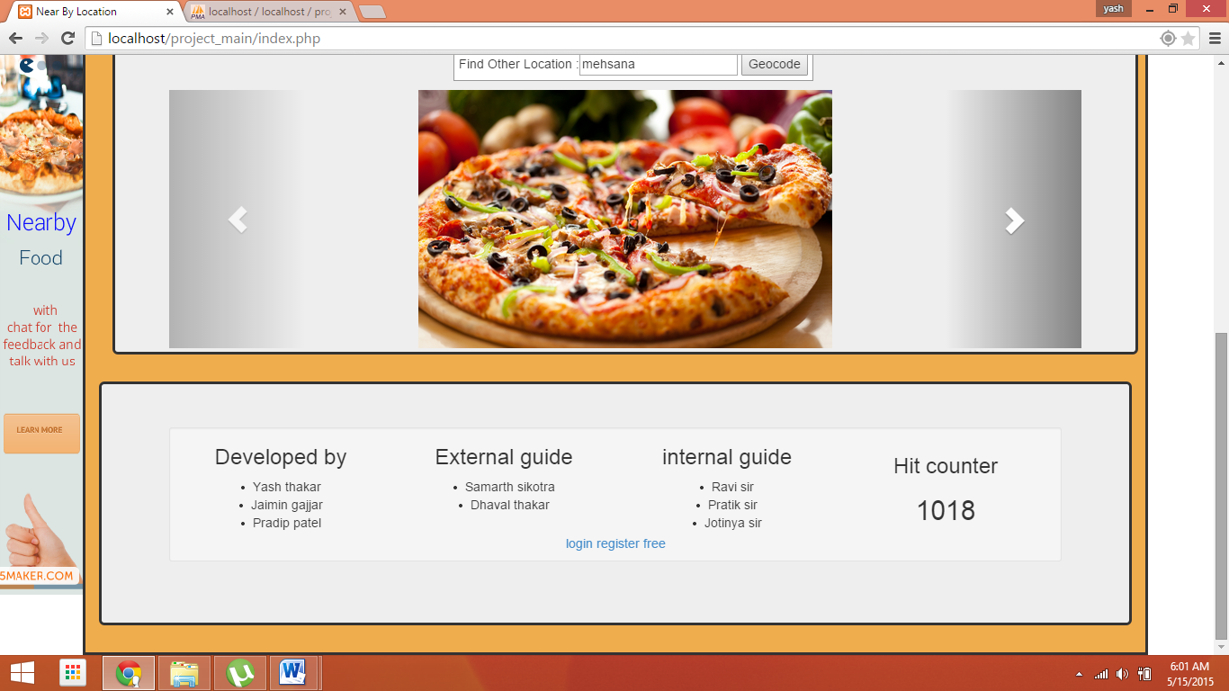

**Chat page**

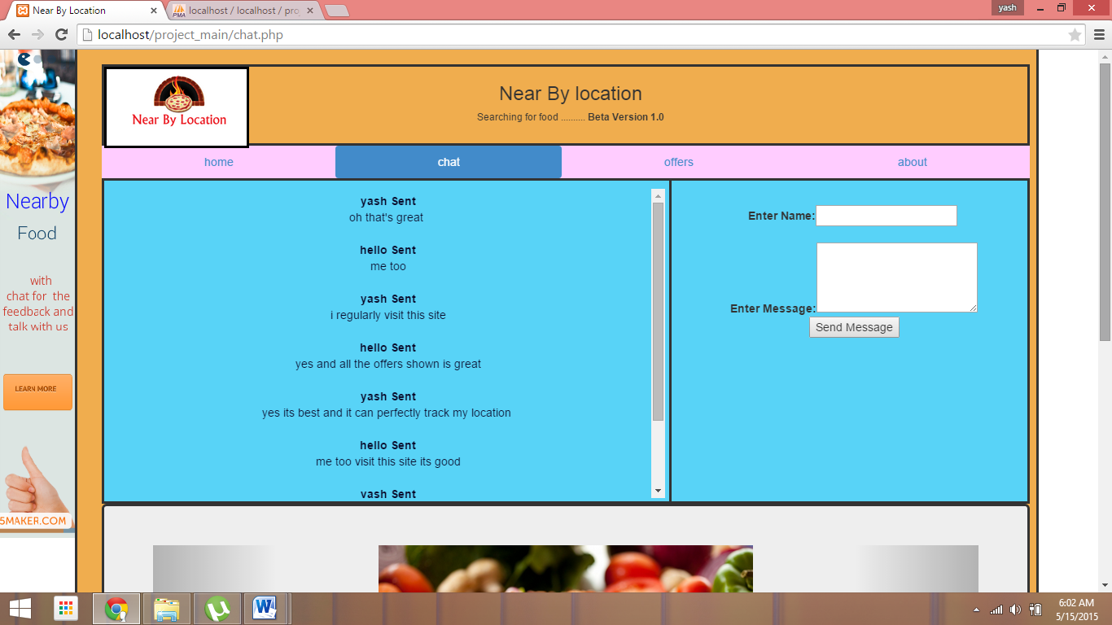

**Offers page**

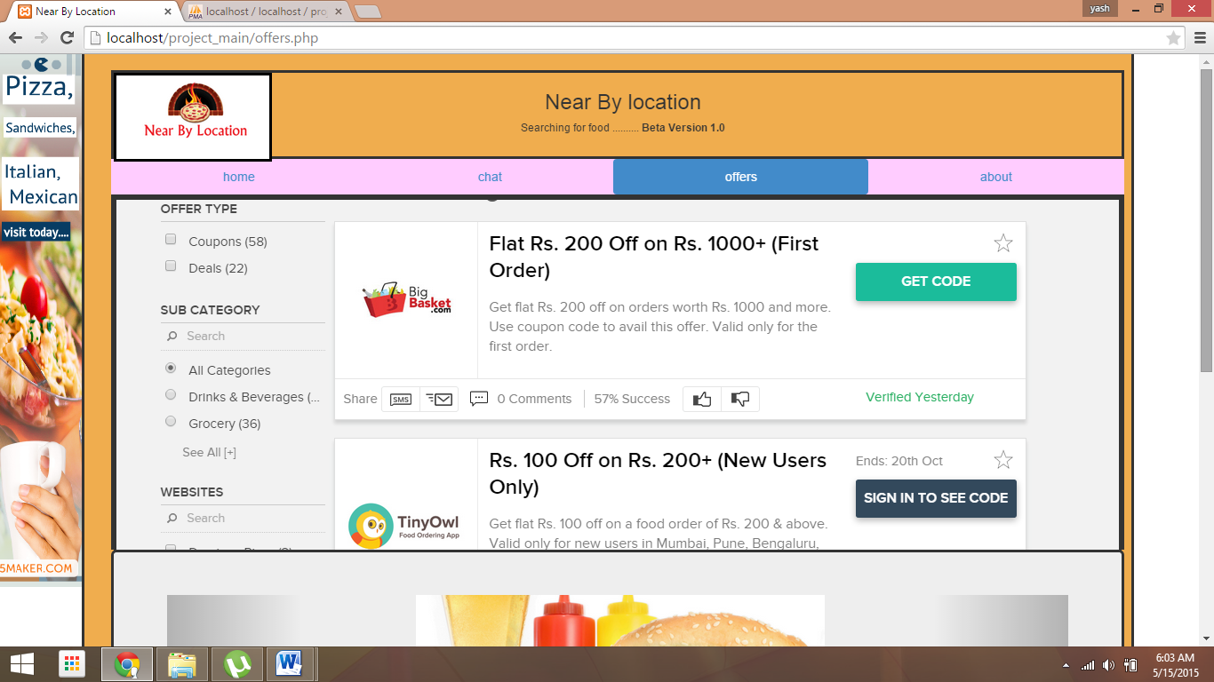

**About page**

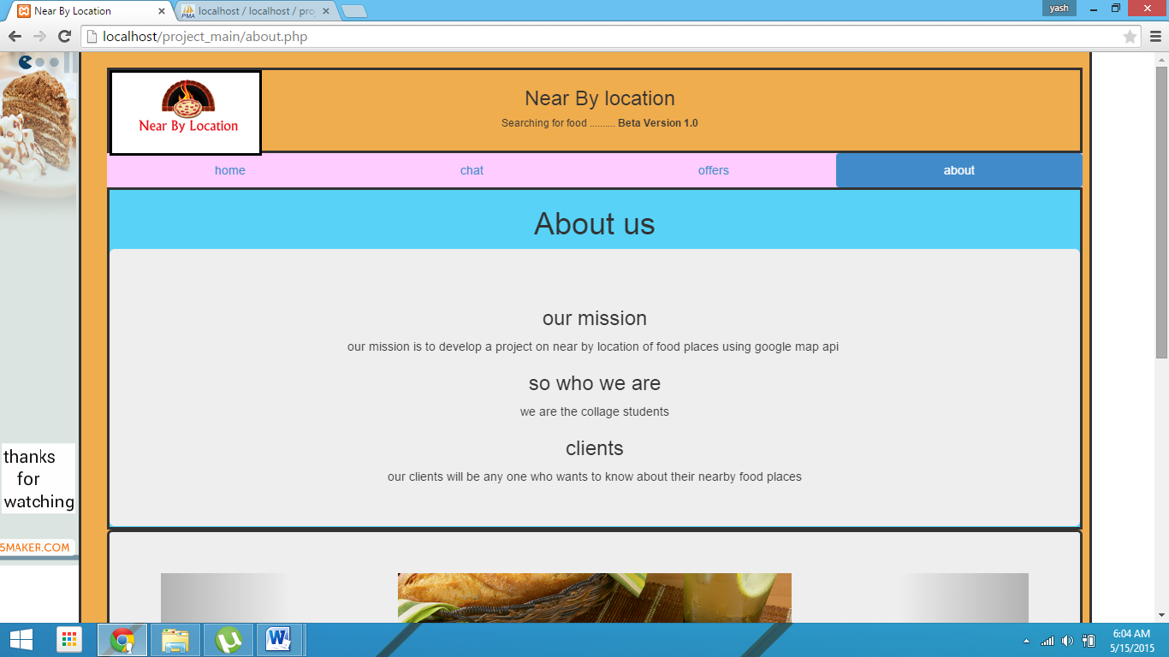

**Registration page**

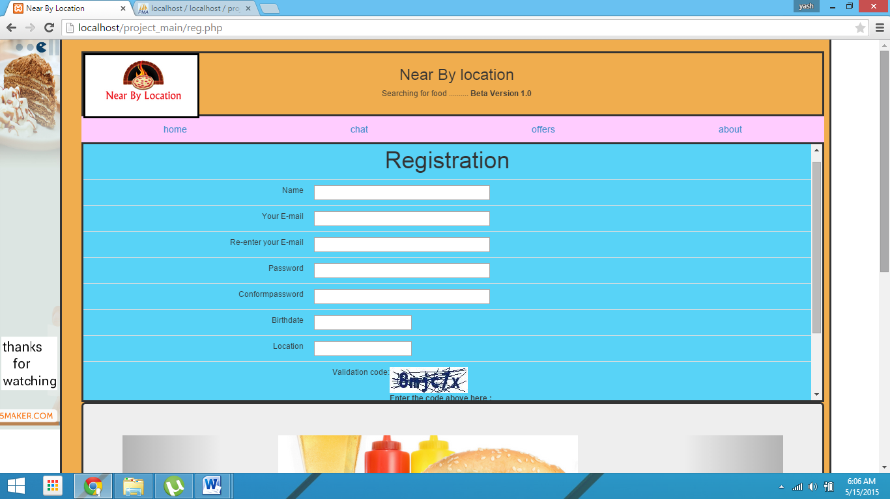

**Login page**

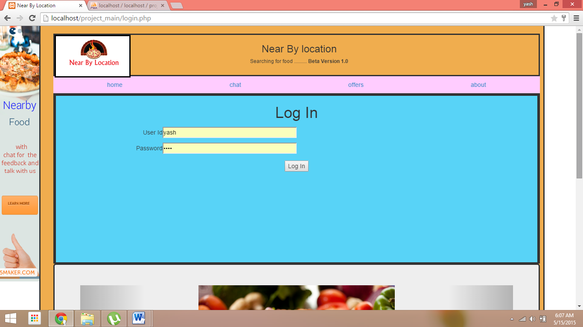

**Admin page**

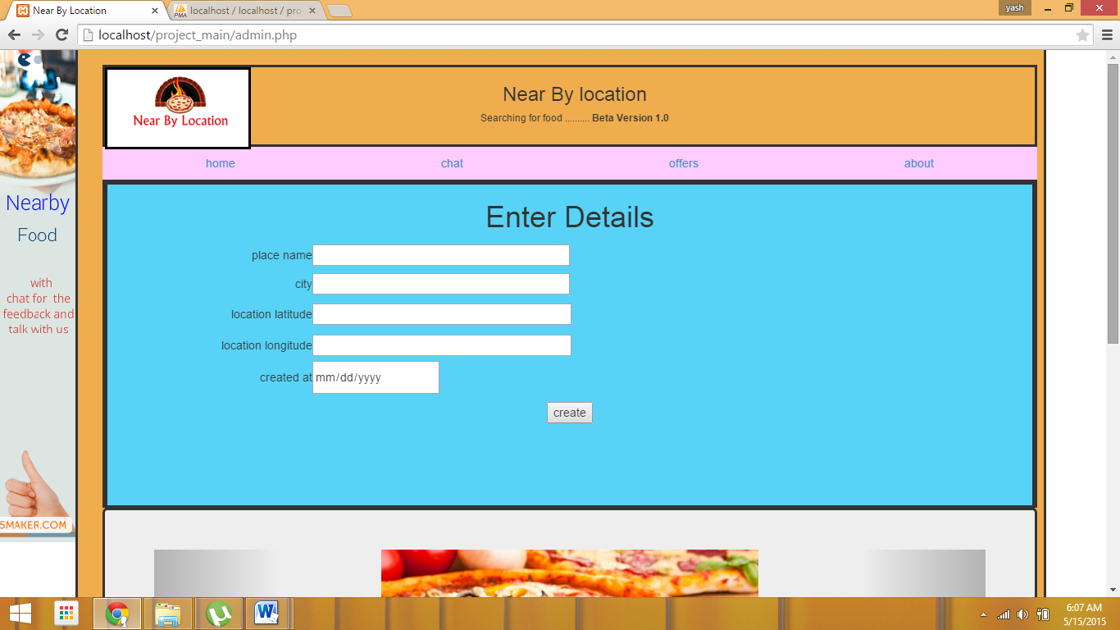

**7. BIBLIOGRAPHY**

**BIBLIOGRAPHY**

* **The reference for making this project is been taken from many websites and some of them are as follows:**

* + [www.w3school.com](http://www.w3school.com/)
  + [www.google.com](http://www.google.com)
  + <https://developers.google.com/maps/>
  + <http://php.net/>
  + <http://getbootstrap.com/>
  + <http://html5maker.com/>